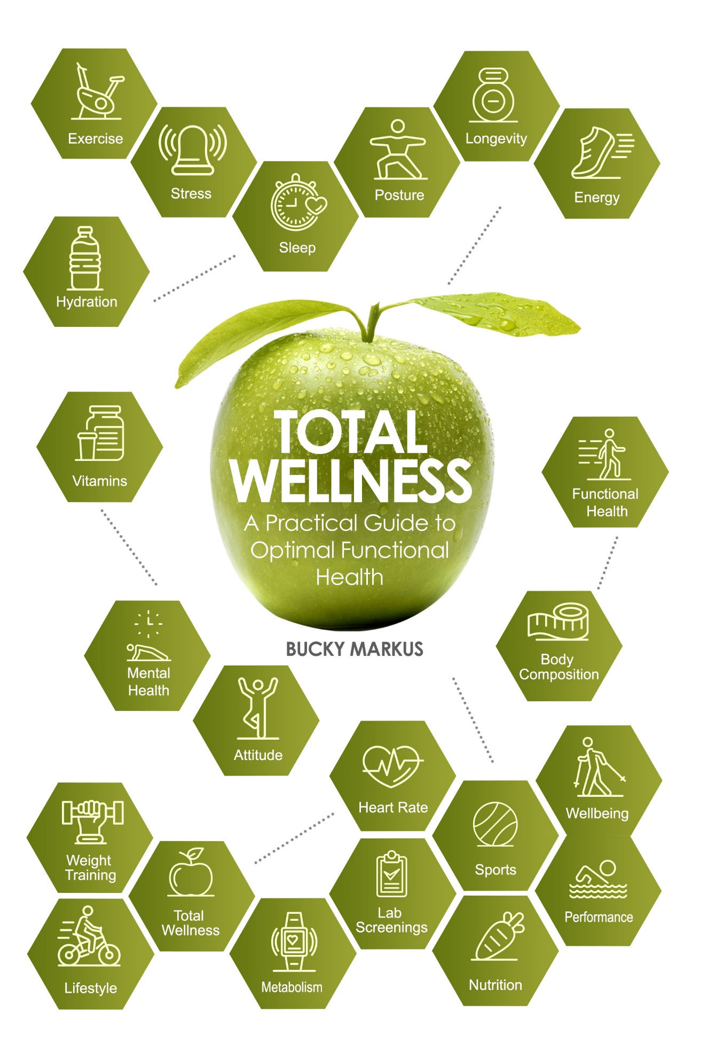

# About the Book

Life is short! Stay on the healthy path and live your best life or achieve your peak performance! To thrive, you will need more than just good health - you will need "Total Wellness," a new paradigm of well-being often called functional health. The core thinking in total wellness is that anything that impairs your ability to function normally in life or any athletic pursuit is compromising your functional health.

This book provides a practical guide towards a more holistic health approach that brings in many elements of your life and not just the physical or mental- offering guidance for those in good or poor health of all ages, athletes, and people living with pain or disease— a must-read for those who are seeking health prevention strategies for longevity or greater vitality. Enjoy your journey!

# Preface

Passion driven, Bucky Markus is writing this book to inspire, educate, motivate, and provide guidance to people from all walks of life on how to improve their functional health or performance. His lifetime of athletics, career experience, and wisdom from aging, has inspired Bucky to write this book.

Bucky's experience to provide valuable content comes from obtaining various licenses, certifications, and college degrees in the field of wellness, as well as from the practical experience of helping hundreds of thousands of people over the last 30 years.

He has assisted individuals to improve their health both in a one on one setting and also through various corporate wellness companies that he has either started or been with. Bucky has also written for various wellness leaders such as <http://wellness.com>, Men's Health, and numerous wellness companies. Seeing lives change or saving lives in addition to helping world-class athletes improve their performance continues to keep Bucky on this meaningful path of health and wellness.

As an educator and speaker, he is driven to keep walking the walk, to grow in his knowledge of his dynamic field, as he continues to help people throughout the world to reach their health goals. Having read many books on wellness and health, Bucky has seen the lack of one good book that brings in a complete picture of "Total Wellness," which is the motivation for this book to capture what he feels are the main pillars of wellness for optimal functional health or performance. People and things in this world are constantly changing, and so is information related to wellness. With this motive in mind, Bucky wanted to bring attention to the main functional health elements all in one place to help people live their best lives.

**Contents**

*Dedication and Acknowledgment i*

*About the Book ii*

*About the Author iii*

*Preface v*

*Chapter 1-* *Total Wellness – Your blueprint for life 1*

*Chapter 2-* *The Foundation of Total Wellness – Nutrition 11*

*Chapter 3-* *Mobility for Life 32*

*Chapter 4-* *Posture for Long Term Wellness 43*

*Chapter 5-* *A Focused Mind Brings Total Wellness 55*

*Chapter 6-* *Positive Thinking – The Attitude for Total Health 67*

*Chapter 7-* *Embracing Our Social Nature 82*

*Chapter 8-* *Embrace Your Spirituality 98*

*Chapter 9-* *Dealing with and Avoiding Stress 113*

*Chapter 10-* *A Breath for Optimal Health 132*

*Chapter 11-* *Sleep Your Way to Total Wellness 148*

*Chapter 12-* *Total Well-being Produces Peak Performance 173*

*Chapter 13-* *Managing Health 194*

*Chapter 14-* *Total Wellness for Total Health 207*